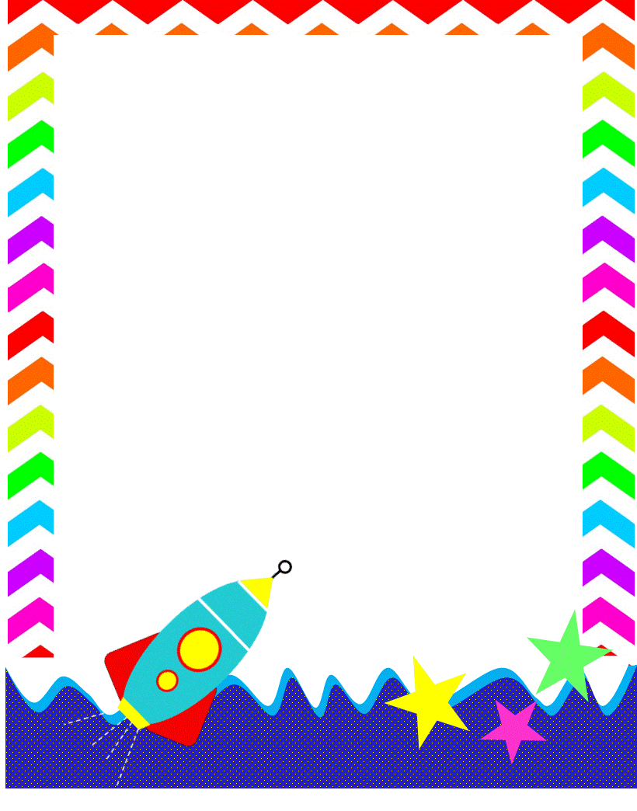**RES Teacher And Staff Favorites List**

**2025-2026**

**Name: Jamila Gilyard Initials: JGB**

**Birthday: 08/06**

**Preferred t-shirt size?  small**

**What is your favorite color?  pink**

**What is your favorite flower/plant?  roses**

**Where are your favorite places to shop?  Target, Sephora, Ulta, Buff City Soap, Publix**

**What are your favorite restaurants?  Cava, Connor’s Steak and Seafood, Riccardo’s, Mom and Dad’s Italian Restaurant, Chipotle**

**What do you collect (candles, foxes, etc.)?  Pearls (costume jewelry), candles (anything with a vanilla or gourmand fragrance)**

**What is your favorite cold drink?  Coca Cola or Cherry Coke**

**What is your favorite hot drink?  Lattes or Cappuccinos**

**What is your favorite sweet treat?  Sugar cookies, dark chocolate or dark chocolate covered nuts**

**What is your favorite salty treat?  almonds**

**What is your favorite fruit?  Strawberries/Pineapples**

**Do you have any food allergies? no**

**Interests: exercising, watching mystery movies, traveling, foodie 😊**

**UMOJA House: Alnazaha**

**Wish list for your classroom?  Disinfectant spray, 2-gallon size zip loc bags, succulent plant(s), baby wipes, 20 small bottles of water (for students), large container of animal crackers, Gemmicc Magnetic Shapes, STEM Toys, and Lincoln Logs**